

**Online Monitoring and Supervision System**

**User’s Manual**

Table of Contents

Chapter 1: General Information 1

Log in to M&S System 2

Downloadable Checklists page 3

Main Interface/Screen 4

Chapter 2: Visit Plan Making by Supervisors and submission of Checklists 5

Plan Making 6

List of Plans made 6

Plan View 7

Make Plan 8

Submission of Checklists 10

Chapter 3: Plan Approval by DHO 11

Plan Approval by DHO 12

View of Approved Plan 14

All Plan View 15

Chapter 4: Plan Approval by DGHS 17

DG All Plan View with Drilldown 18

View Approved plan with Drilldown facility 19

Chapter 5: Reports 21

Chapter 6: Dashboard 25

# Chapter 1: General Information

## Log in to M&S System

To login in the Online M&S software, follow the instructions provided here;

Type the web address mnskp.pacemis.com here in your browser to open the M&S application login page.

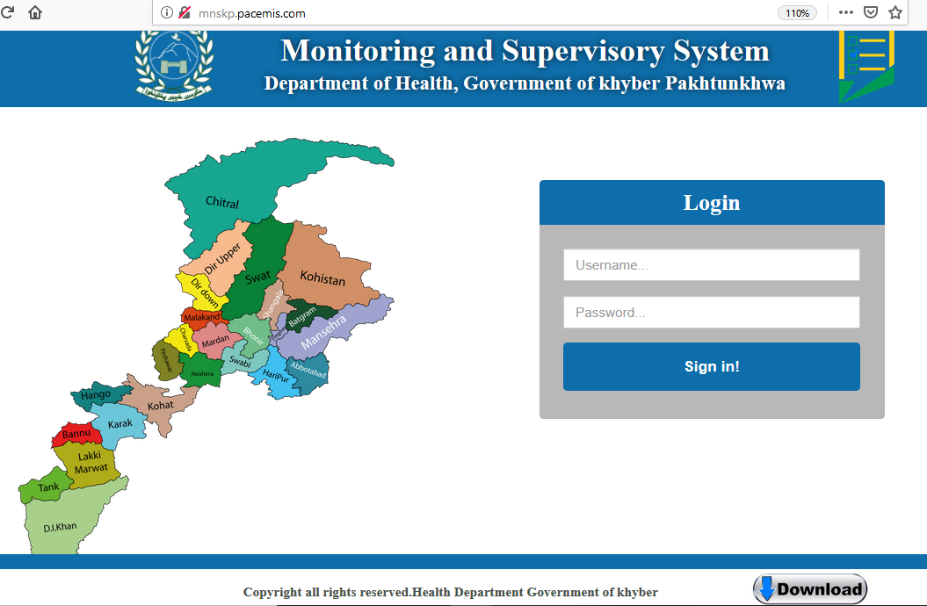

Clicking on Download will take you to the page containing all downloadable checklists without logging in to the system

Enter your **Username** here, this is case sensitive input.

Enter your **Password** here, this is case sensitive input.

After entering your User name and Password, Click **Login** button

## Downloadable Checklists page

This page consists of all checklists in downloadable word and pdf formats. Supervisors may download these checklists and forms to make monthly visits plan. Before entering data of visit plan and filled checklists into online system, these forms may be filled by supervisors during health facilities visits

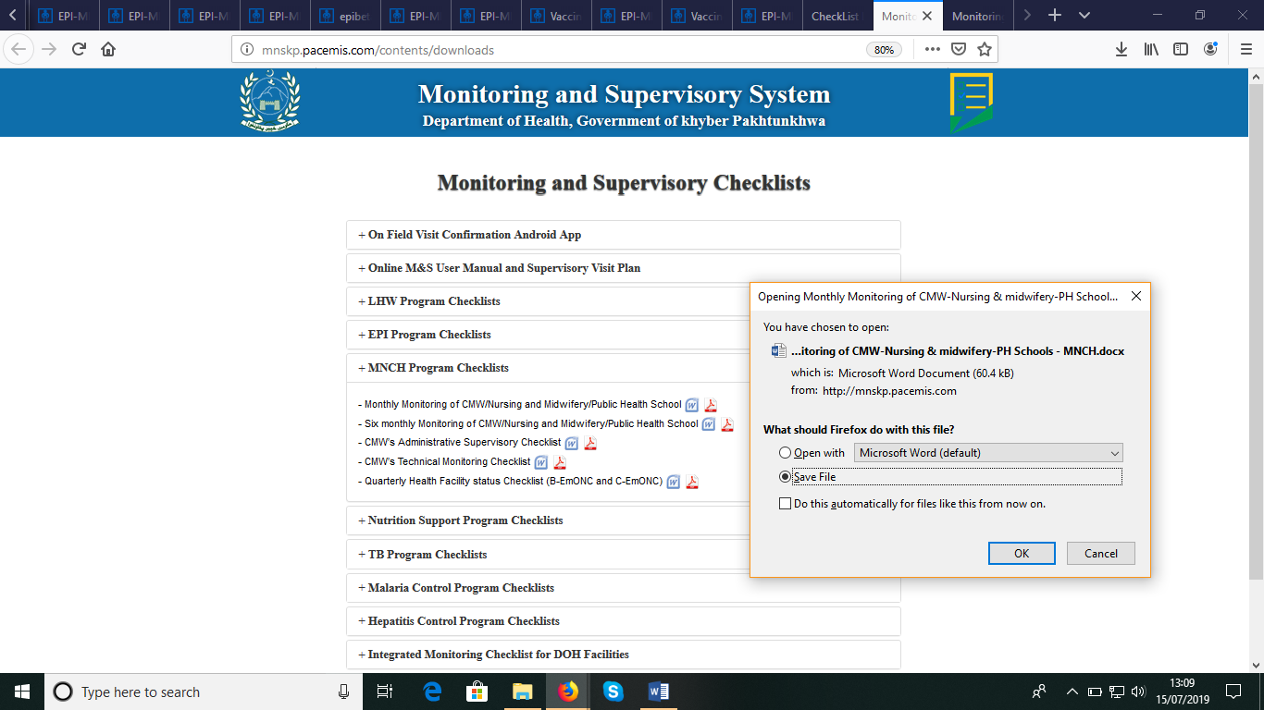

Downloadable Supervisory checklists

File download dialog box after clicking on word or pdf icon

Click + to explore list of checklists in this section

## Main Interface/Screen

After login in, following screen will be appeared in your web browser; top left hand side showing the logo of province and the top right hand side show the details of supervisor’s login, designations and program. After header, there is menu bar contain all options to interact with system

District name

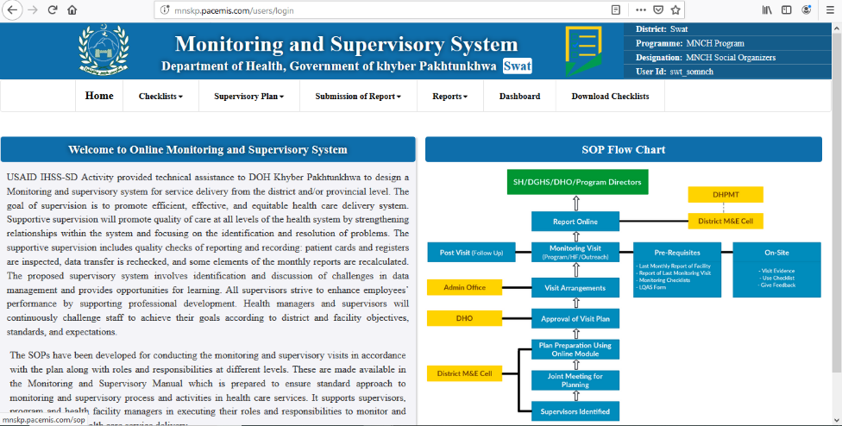

Click on this link to read the details about SOP

Menu bar showing the different options for working

The flow diagram to show operating procedure

Program, Designation and login id of Supervisor logged in the System

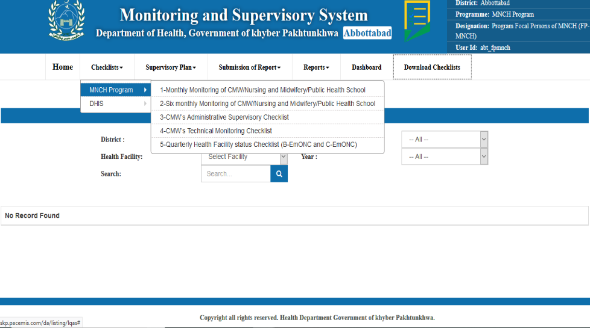

Menu Options for MNCH Supervisor. Every supervisor will see checklists of their relevant programs

# 

# Chapter 2: Visit Plan Making by Supervisors and submission of Checklists

## 

## Plan Making

Every district and provincial supervisor may make his own plan. To add/edit or view his plan, supervisor has to click on My Plan in menu as shown the following.

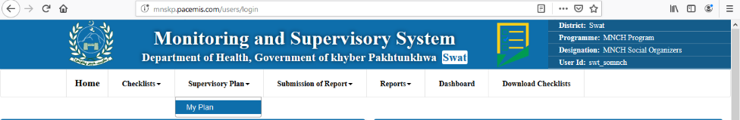

Supervisor will click on My plan to add/edit of view their plans

## List of Plans made

Next screen appear will contain the list of plans made by the supervisor. This list contains information like Supervisor name, District, Year month, supervisors program, No of visits planed, plan submission date, information whether plan is approved by DHO and view button to see the details of plan

On top of list, there is a link “Make Plan”, clicking on this will open the interface to make new plan.

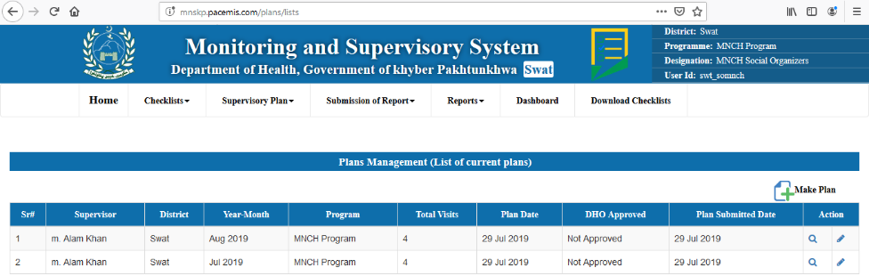

Click here to make new plan

Click here to see the details of plan

List of plans made by supervisor

Click here to edit the details of plan

## Plan View

Clicking on Plan view will open the page containing details of plan. These details include information about Supervisor who made the plan, year-month of the plan, details about each planned visit which includes visit category (DAP visit / Program visits), Facility type, Facility to be visited, Checklist names to be filled during visit, Healthcare providers name whose checklist is to be filled, date of visit planned.

Details of supervisor information and plan year month

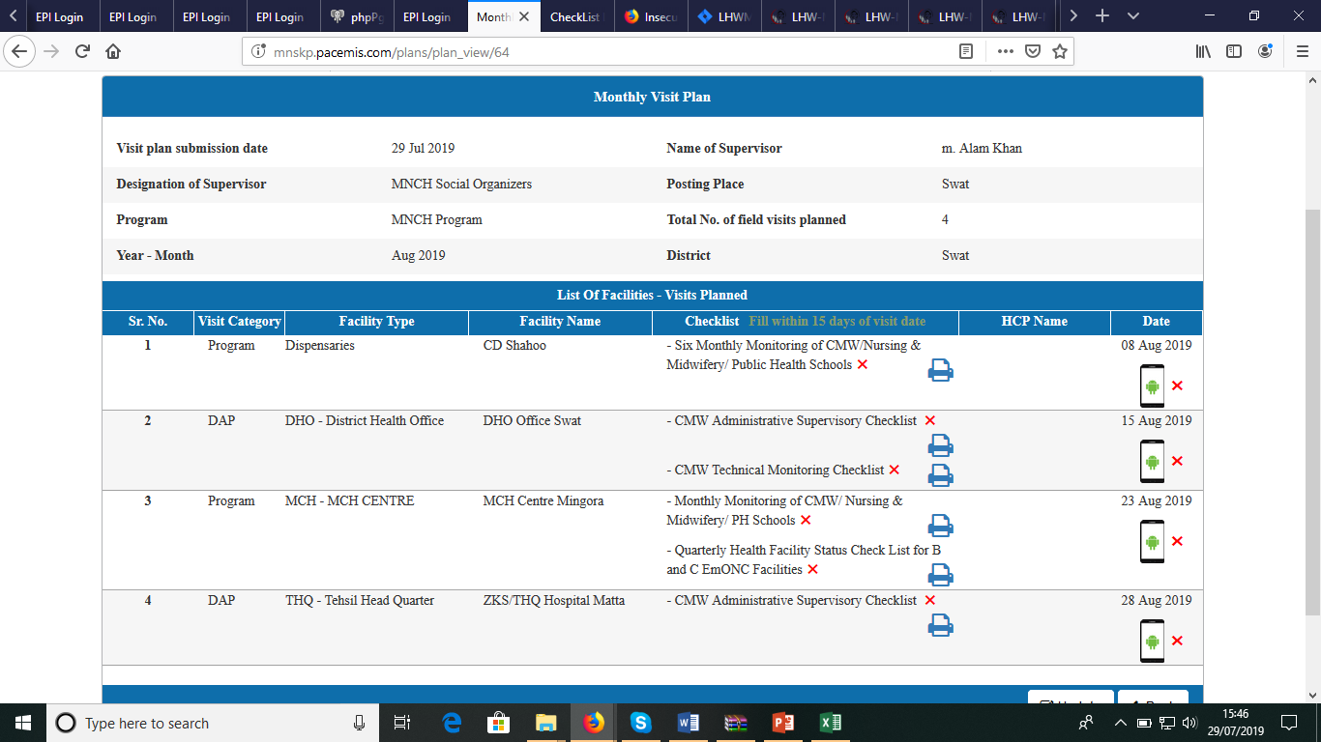

“**√**” or “**X**” indicates that it is filled in system or not. If filled it can be viewed

Mobile is indicator to show whether it is confirmed from mobile or not

Selected Checklists to be filled during planned visit can be print from this button

“**√**” or “**X**” indicates that it is confirmed or not. If confirmed it can be viewed

Health Facility name to be visited

## Make Plan

By clicking on Make plan, interface of making new plan for the month will be appeared. This interface will facilitate supervisors to make plan for coming month, by selecting visit category, health facility to be visited, checklist to be filled and any particular health care provider whose checklist to be filled like CMW, LHW and any SBA, and dates when health facilities will be visited in plan. Following figures show the functioning of Make new plan

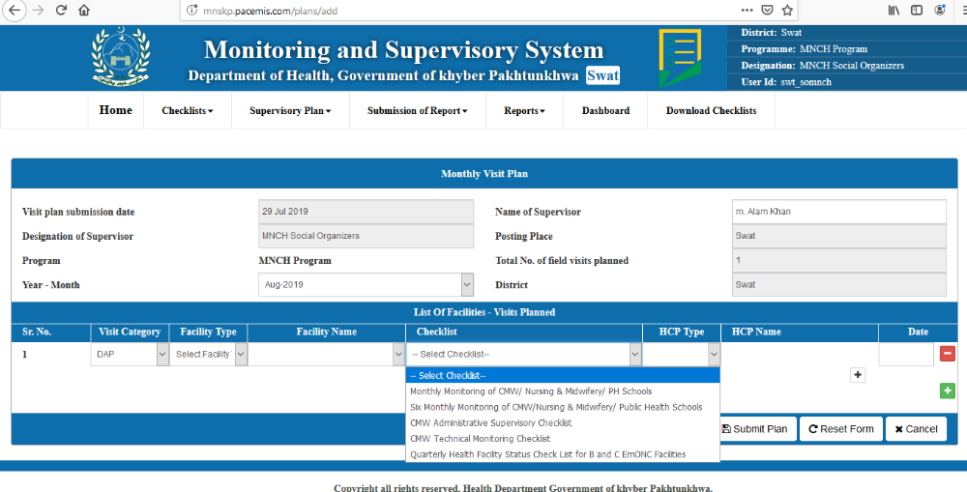

To enter name of supervisor and posting place

Year-Month of the plan

This button allows to add more than one checklist to be filled during visit

Checklists to be filled during visit.

Visit Category is either DAP or Routine Vertical Program

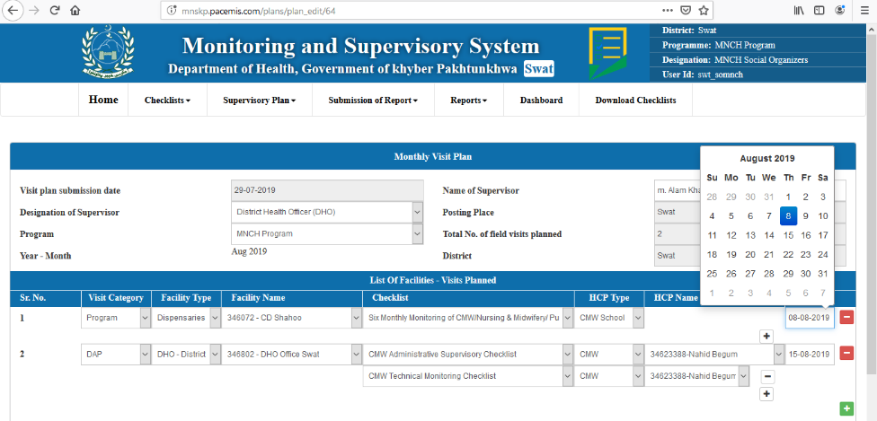

Facility type will filter the facility of particular types

Facility to be visited

Healthcare provider to be selected whose checklists to be filled

Date of the visit

This button allows to add new visit

* Visit plan is editable until approved by DHO. After the approval of DHO, this plan may not be changed
* Supervisor has facility to select as many checklists he want to filled during one visit
* Supervisor may add as many visit as he wants to include in plan
* One supervisor may make only one plan for a month. If plan already exist, then following message will appear

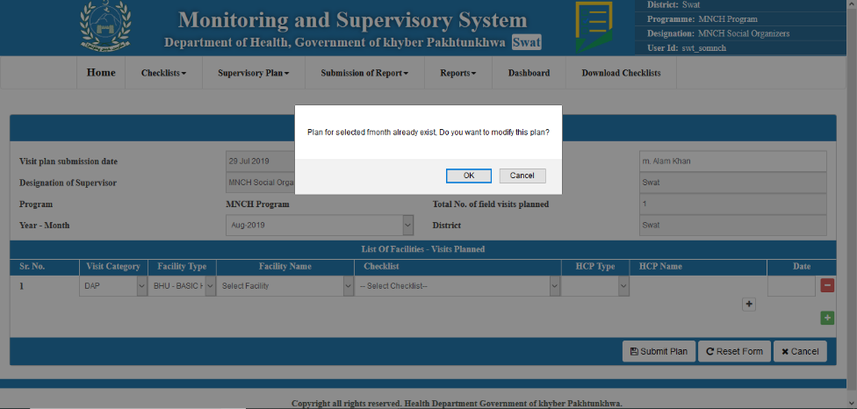

## Submission of Checklists

After the plan is made, and DHO will approve the plan, Supervisors will visit facilities and fill checklists during their visits as per plan. Then supervisors will be able submit data of this checklist in online system. For submission of checklist, Supervisor will click on Submission of Report” which will give month list whose plans are available.

Submission of Report  
List of month whose plan are available for submission

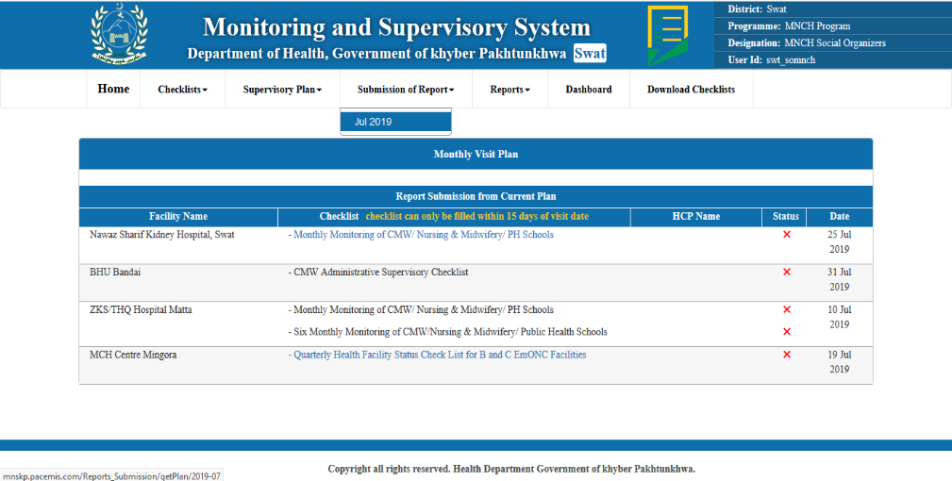

Click on checklist to enter checklist data online

“**√**” or “**X**” tells the status of checklist filled

# Chapter 3: Plan Approval by DHO

## Plan Approval by DHO

For district supervisor, DHO is allowed to approve the plan in this system. Similarly, for provincial supervisor of vertical programs, Provincial program director is allowed to approve the plan. DHO or Provincial program director will first login to the system.

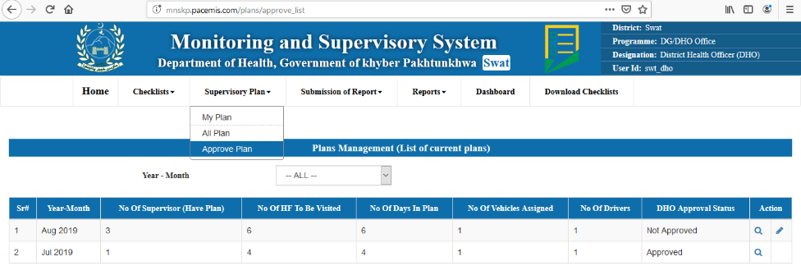

DHO Login

Approve Plan

DHO will be able to see full list of checklists in menu

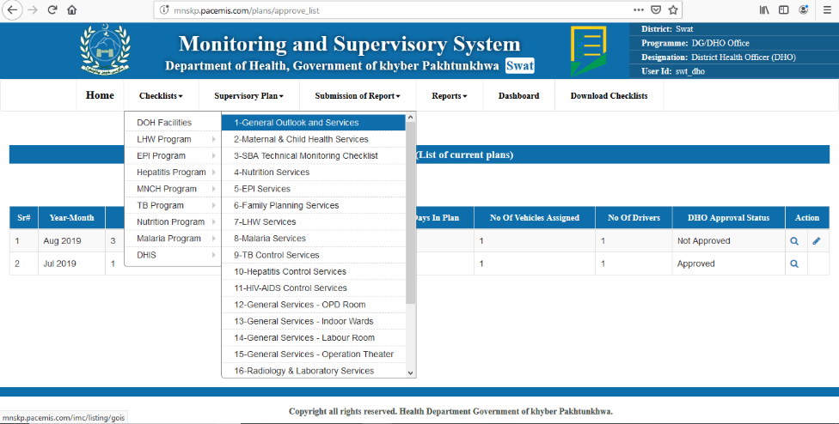

After clicking Approve Plan following screen will appear. Here DHO can view the list of approved and unapproved plans.

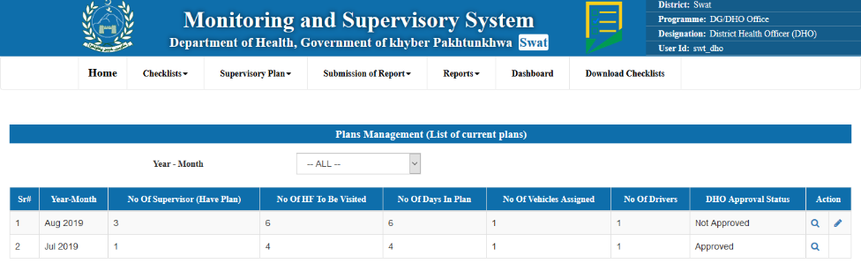

To View and Edit the approve and unapproved plans

When clicked on view plan it shows the following view for the selected plan of month

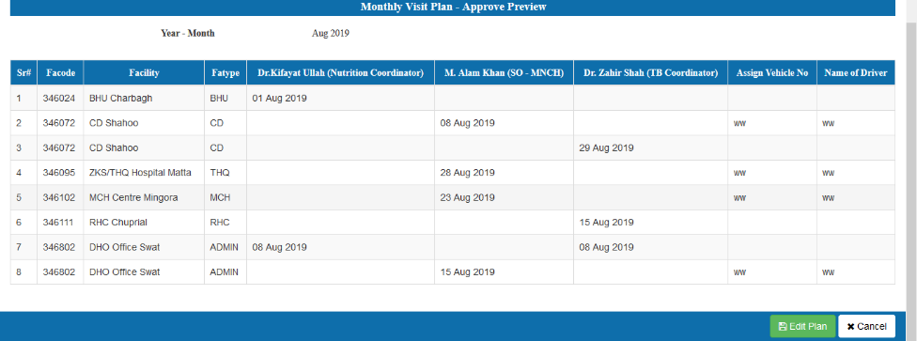

Dates of Supervisor may be adjusted by DHO to optimize the plan

DHO may Edit the existing plan

To approve plan, when click on edit button, the following screen will appear. From where a plan can be approved by DHO and can be edited if required.

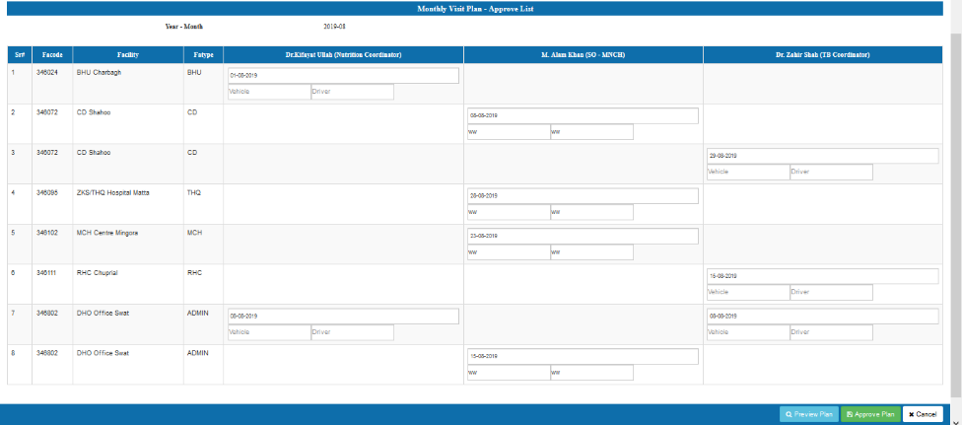

DHO will click this button to finalize and approve Plan

## View of Approved Plan

DHO may view his approved plan by clicking on view in plan lists. 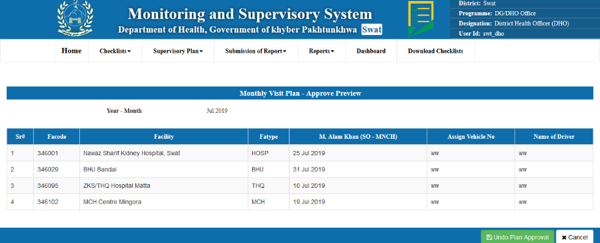

## All Plan View

DHO will click this button to Undo approved Plan

DHO may have view of all plans by clicking All Plan in menu of Supervisory Plans. Following is the view of All plans for DHO

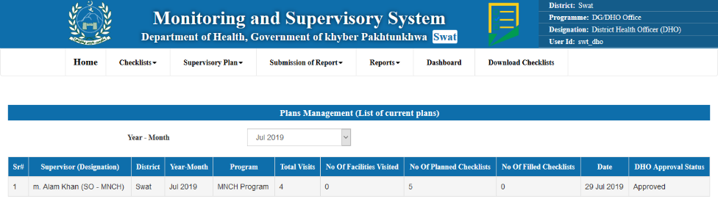

Clicking on any row will give drill down plan view of any supervisor

Drill down view of plan after clicking on any row of all plan view of DHO

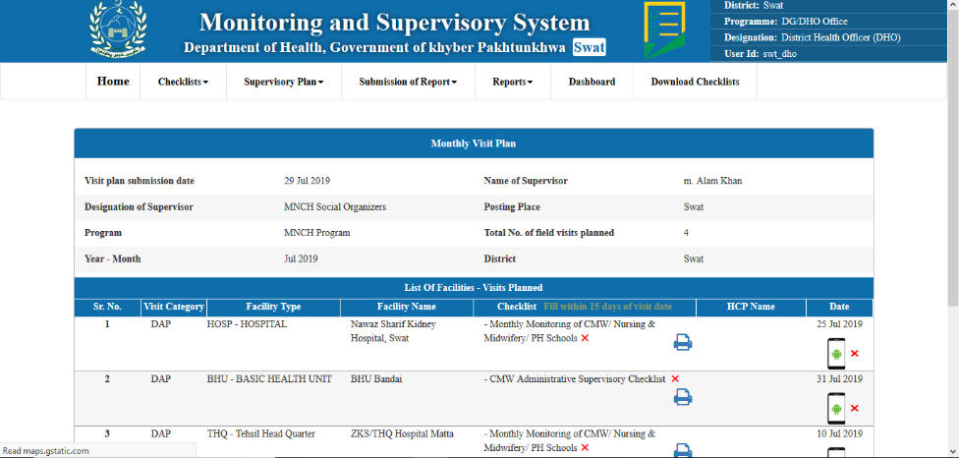

“**√**” or “**X**” tells the status of checklist filled.

Clicking on Checklist will give view of filled checklist as drilldown

Then in plan detailed view, DHO may click on any checklist, it will open view of filled checklist as drilldown

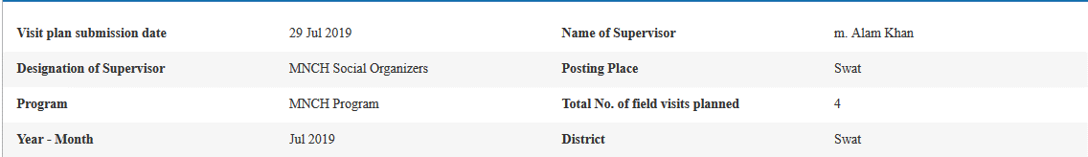

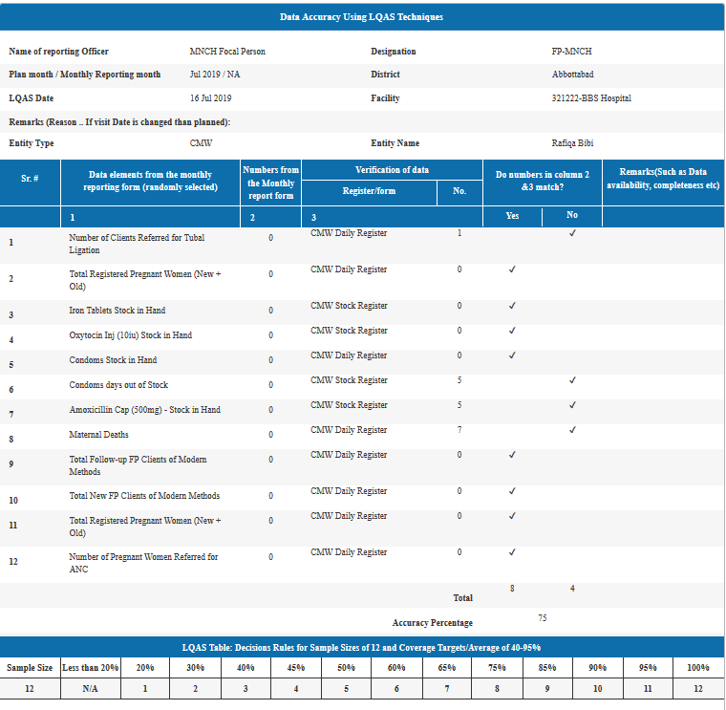

This is view of sampled filled checklist of Data Accuracy using LQAS techniques. This view is showing that this checklist is filled by FP-MNCH for reporting month July 2019.

# Chapter 4: Plan Approval by DGHS

## DG All Plan View with Drilldown

DG health also can view all plans made by supervisor and approved by DHOs by clicking on All plan from menu. This view of all plans gives information about plans submitted as district wise aggregates. This view includes no of supervisor who have made their plans, No of days in plan for every district, No of Health facilities to be visited, No of vehicles to be used or assigned, No of Drivers assigned against district’s plan. This view has the features of drilldown therefore DGHS may click on any row and get the view of details of districts

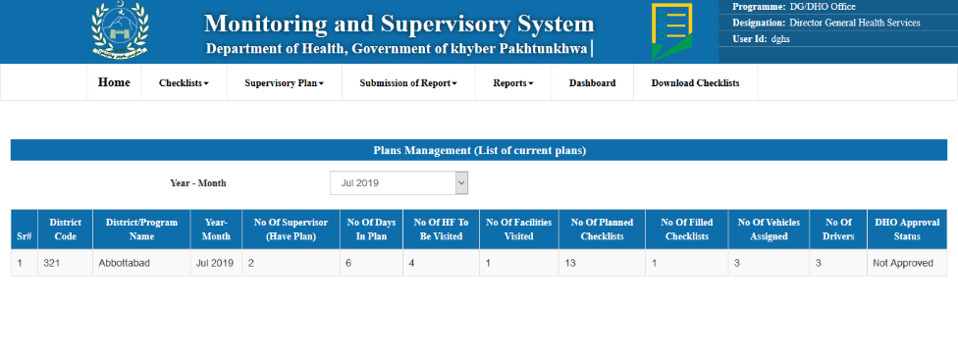

View of details of districts which is shown in following snapshot.

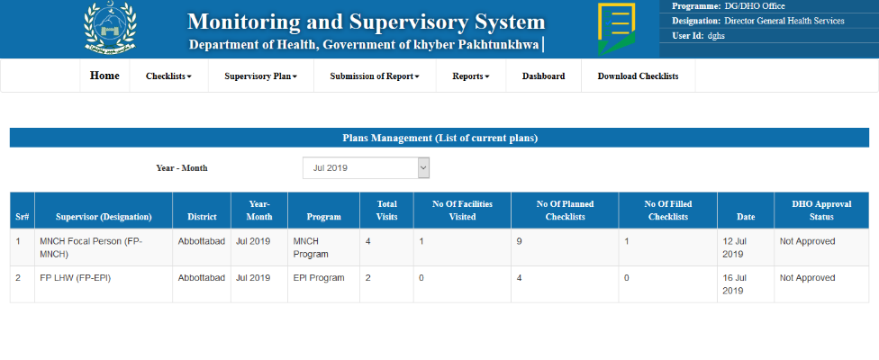

Drilldown to view the further monthly plan created by supervisor.

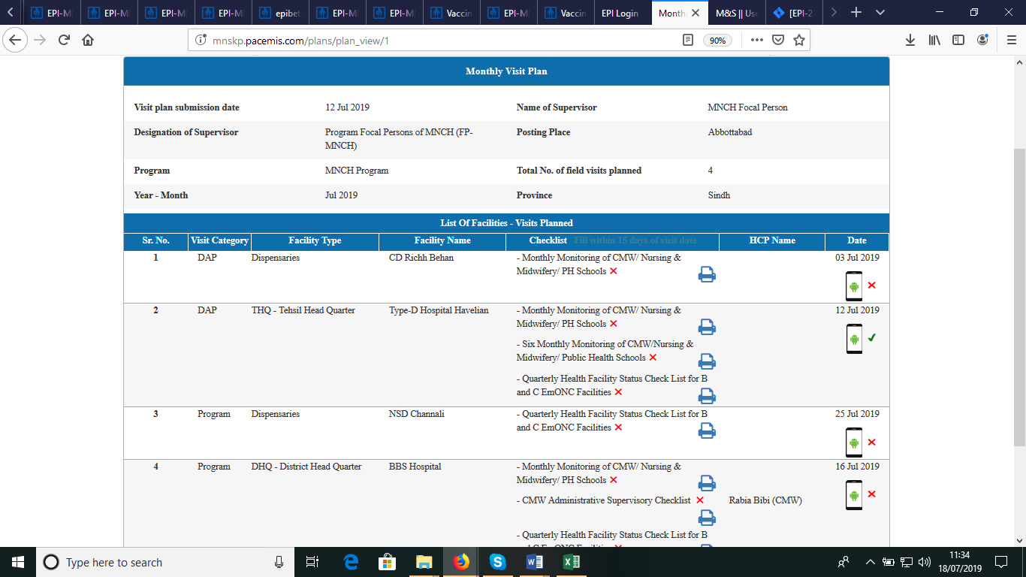

## View Approved plan with Drilldown facility

DGHS may view all plans by clicking on Approved Plans in menu of Supervisory plans. Which shows the aggregated data of plan submitted for each month including total districts who have made the plan in one month, Number of health facilities to be visited, supervisor in plan, days, Number of vehicles to be used and drivers assigned to them. View of approved plans will be as follows.

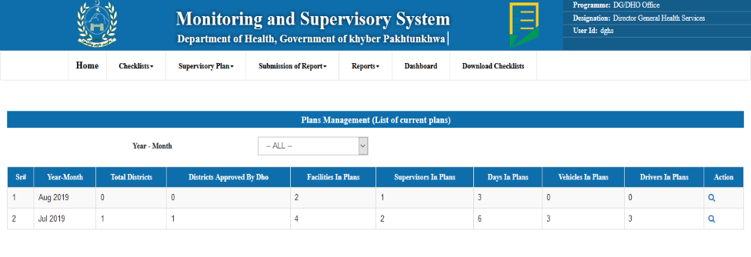

To view the plan for each month

To view the plans in selected month click on view button, the following list of plans will occur which further drilldown to the facilities.

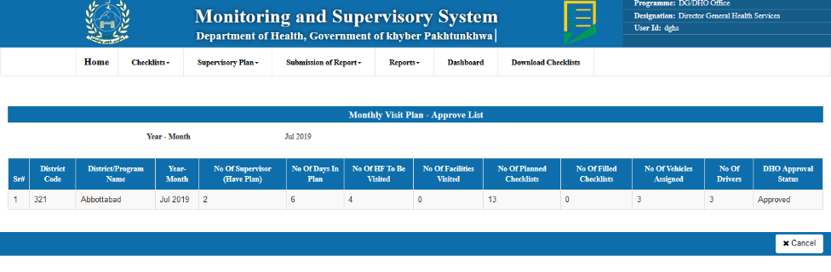

Further drilldown to gives the detail of every supervisor plan created in selected district. Which shows the information of facilities to visit, date on which person has to visit along with the information of assigned drivers and vehicles.

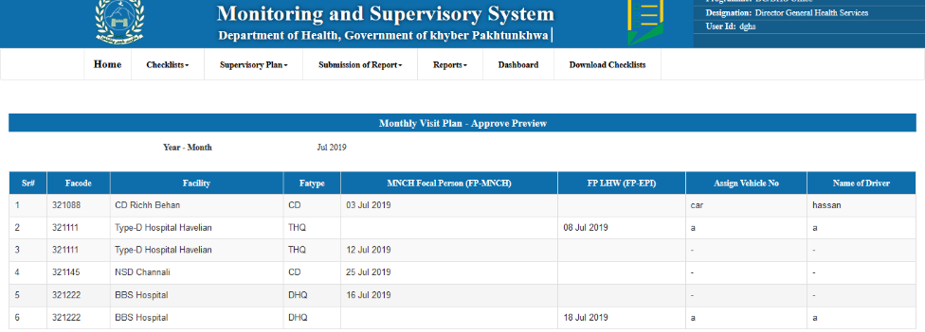

# Chapter 5: Reports

Dghs, supervisor and other user can view the reports in their menu to get the compliance reports of checklists and other reports.

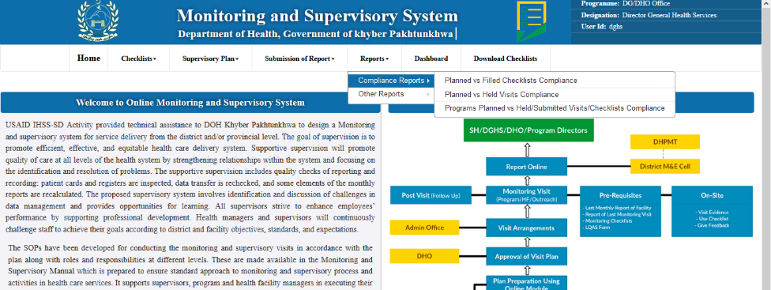

The compliance and other reports can be selected from this menu

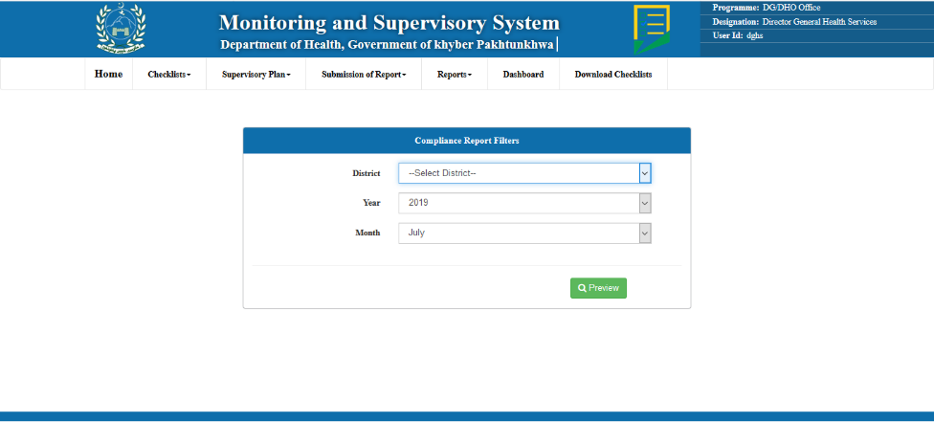

To preview the report

This dropdown gives the list of year

To select month, click on month dropdown

District can be selected from dropdown

The preview of report is following.

To print and download this report in different format

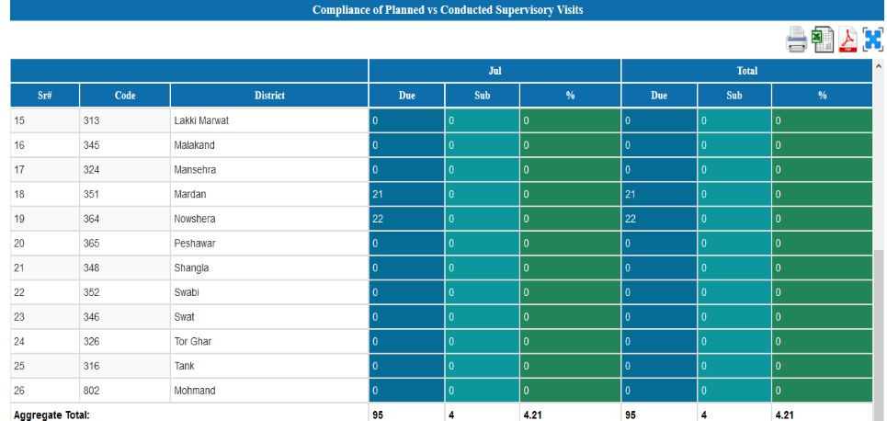

The Aggregated Total for all district

Click on any row to drilldown to the detail report for any district

Drilldown view for any clicked row is down below

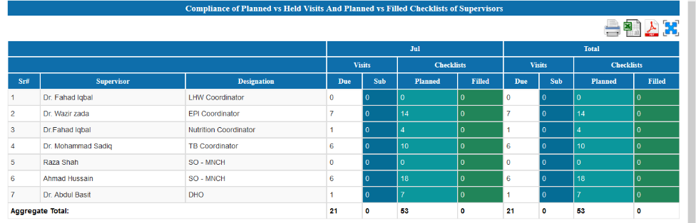

Click on any row to drilldown for details of plan

Further drilldown provide the view like shown below

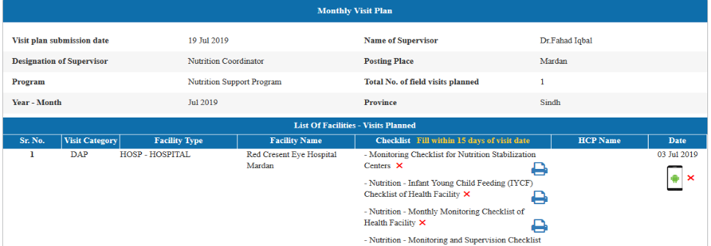

The view for other report is shown below.

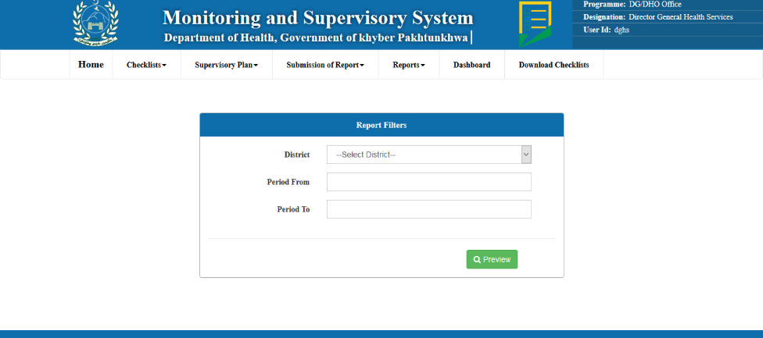

Select date from and to for report of desired time period.

# 

# Chapter 6: Dashboard

All users can view the dashboard to view the count of plans, created, visited, filled checklists, HF in plan and others by clicking on Dashboard from the main menu. Which further provide the details of every selected option depending upon the periodical frequency. Dashboard contains monthly calendar, indicator wise trend, periodic trend, mobile verified visits maps, LQAS checklist trend and Gap Analysis.

When dghs user login, the view for dashboard is shown below. In which it shows the total count for every indicator district wise and drilldown gives the detail table for every supervisor which further results in giving the detail of plan created by further drilldown.

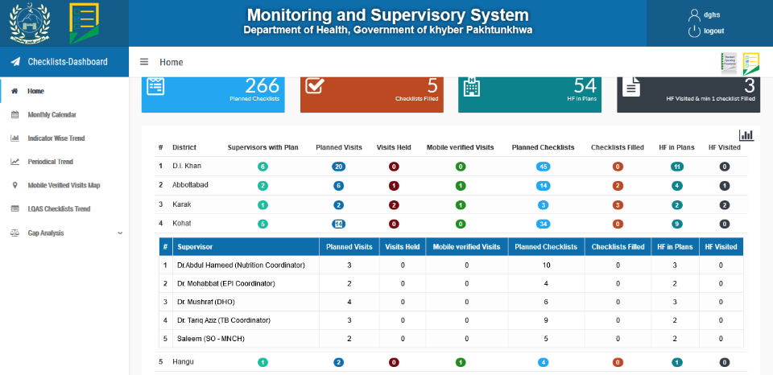

This table shows the detail of plans created by supervisor for district. Drilldown on any row gives the detail view of plan.

Drilldown on any indicator shows the table shown below

When user login from supervisor the view for dashboard is following

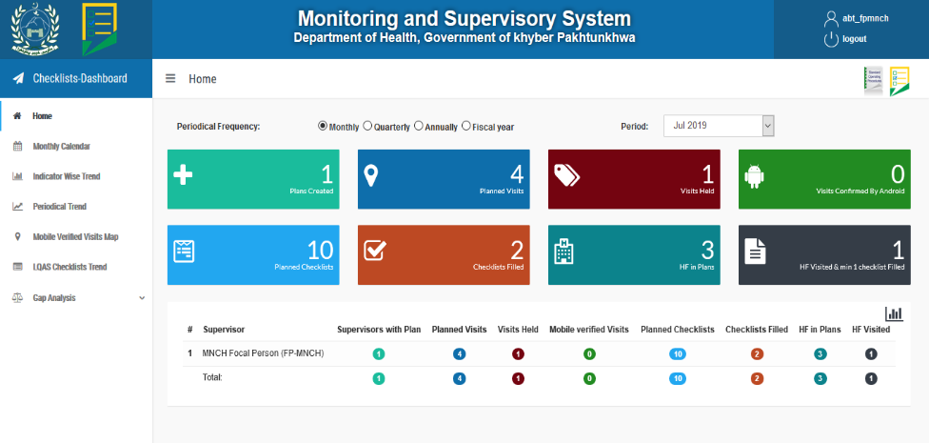

Every indicator in Boxes shows the total count. e.g planned visits

To view detail of indicators in graphs.

Count, drilldown to view the planned visited

When clicked on the graph icon, it shows the information in graphs.

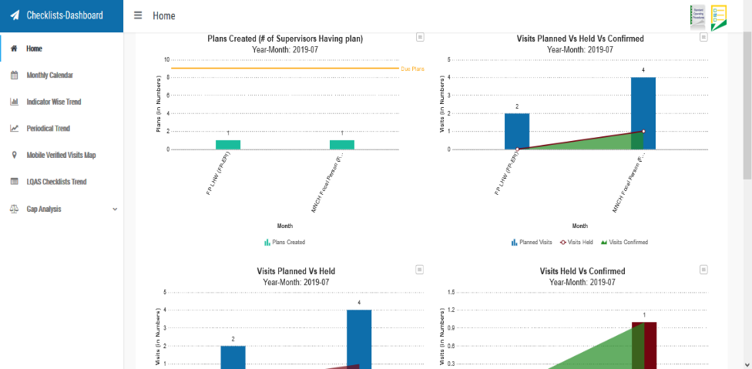

In Monthly Calendar, it shows the plans created on specific dates with the details of visited and confirmed plans, planned checklists and filled checklists. In which drilldown to any option gives the further detail about planned and filled checklists.

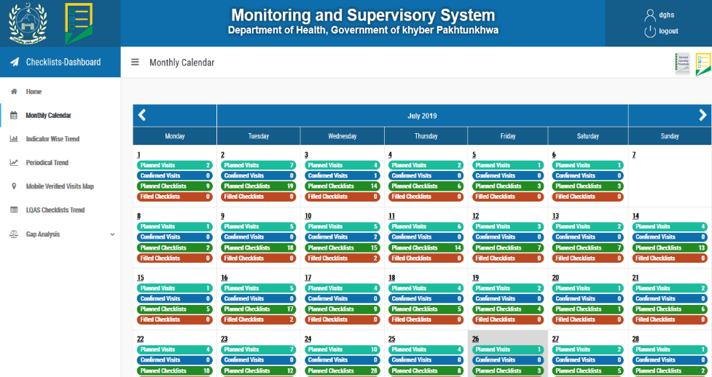

For previous month’s plan

For next month’s plan

Click on any option to view the details of planned visit

Following is the drilldown view, when clicked on any option on plans for respective dates

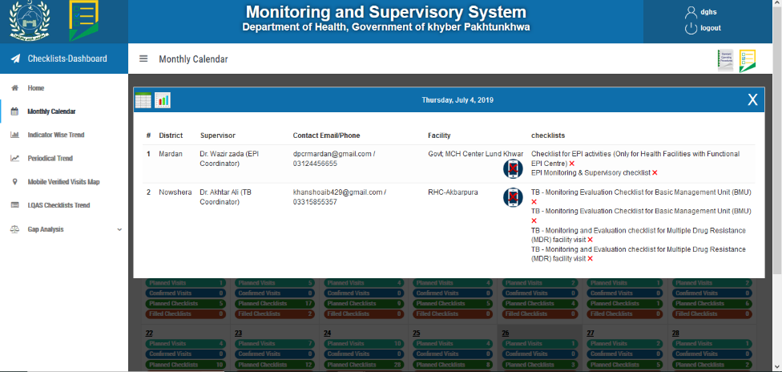

Below is the view of Indicator Wise Trend for created and visited plans and visits planed vs Held and visits held vs confirmed, checklists planned vs filled and HF planned vs visited depending upon the year, district and program. 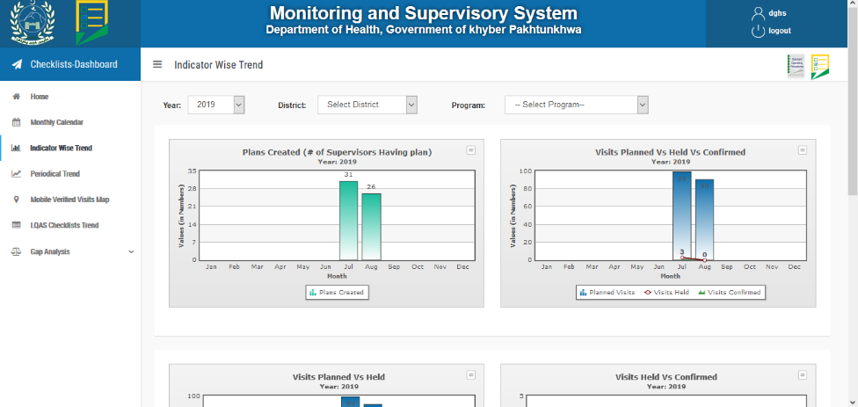

Periodical Trend shows the trends for all the indicators periodically including, monthly, quarterly and yearly. Following are the views for periodical trends

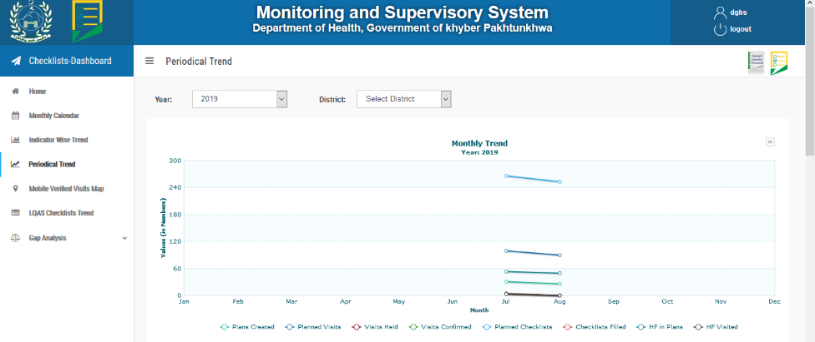

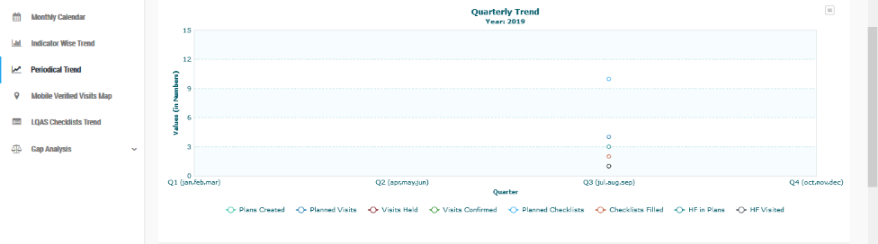

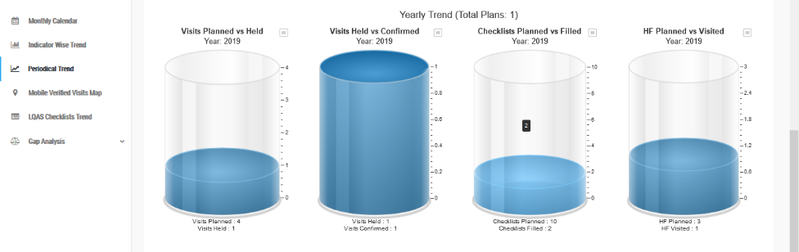

Mobile Verified Visits Map provides the information through maps that where the planned visit held and when they confirmed from mobile application it shows on the map when clicked on the icon.

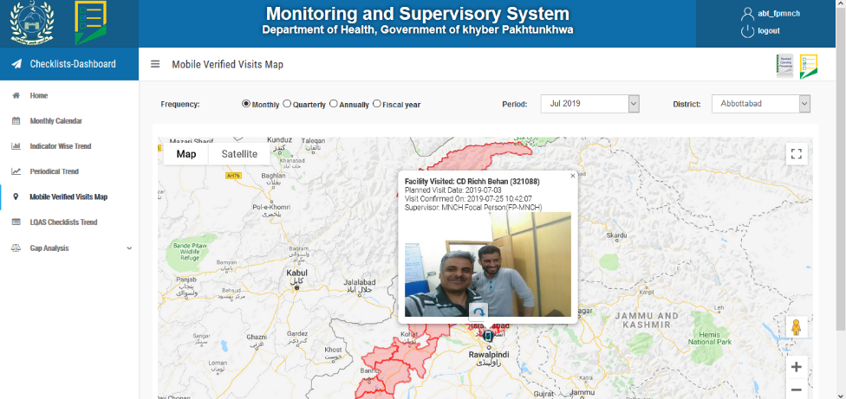

To see the details where the plan is visited, click on mobile icon

LQAS Checklists Trend shows the trend of indicators for checklist planned vs filled periodically (Monthly, Quarterly and yearly) as well as district wise and program wise.

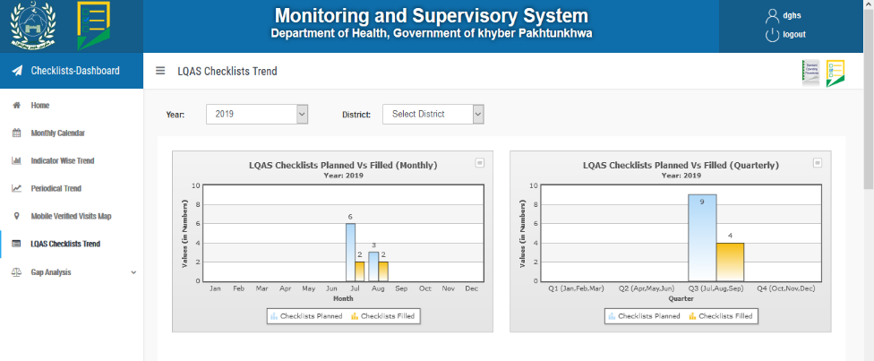

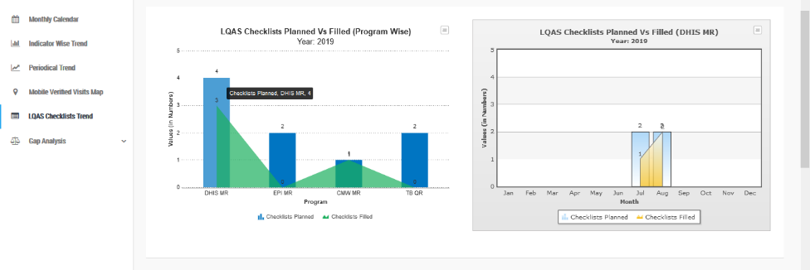

Clicking on bars in graph gives the yearly graph for specific program

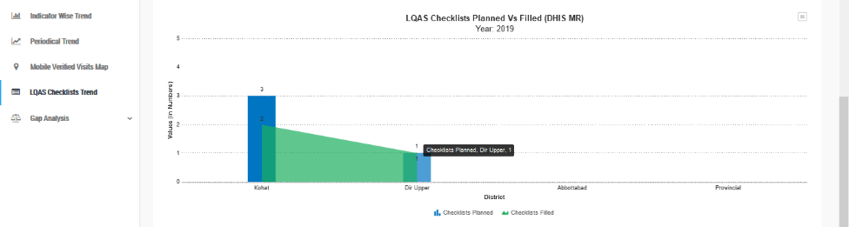

Gap Analysis

To analyze the availability and non-availability of resources, Gap Analysis provides the information of each indicator in the checklists through graphs for every program.

Integral monitoring shows all the indicators included in checklist which can be selected from dropdown and gives the complete picture to analyze the resources. 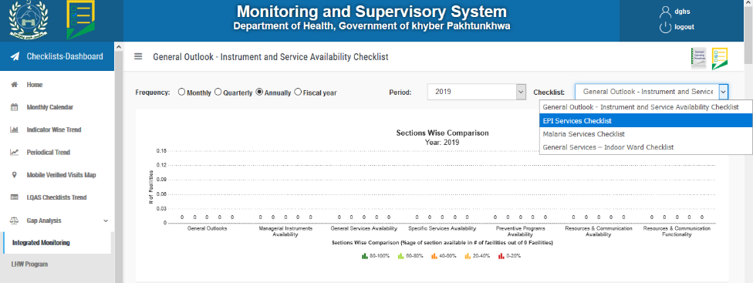

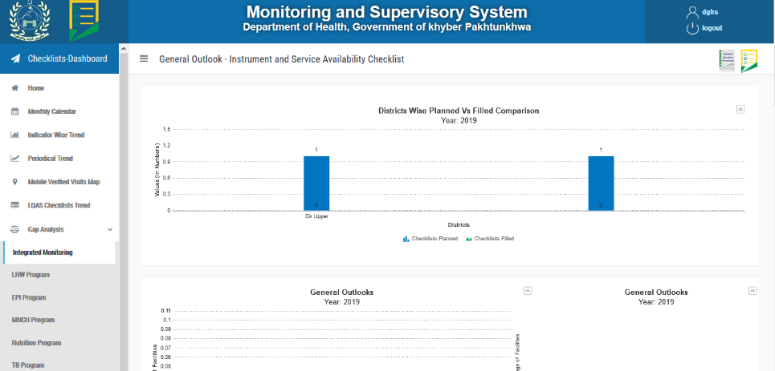

This following image show the information for checklist in LHW program to analyze the resources included.

